Activity – Analyzing Current in Series and Parallel Circuits

Name: ___________________ Date: ____________________ Block: ____________

For this lab you will be using the simulation software from the following website: http://phet.colorado.edu/new/simulations/ → physics - electricity -click on the Circuit Construction Site (DC only + HTML5 choose LAB)

Recall - Investigating Voltage

- What does being in series mean?

- When you increased the number of cells in series in a circuit, what happened to the potential difference (voltage) in the circuit?

Identify the Circuit

State whether the diagrams below are a parallel or series circuit. Note: the diagrams provided below are not closed circuits.

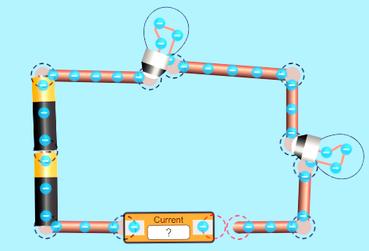
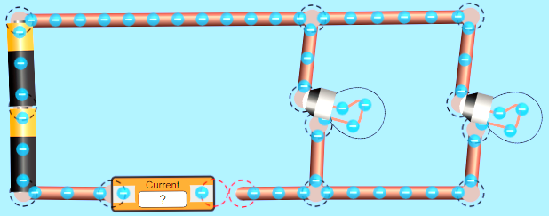

This circuit is_________________ because
This circuit is_________________ because

Series Circuit - Investigating Current

You will create 3 different series circuits that will always involve two cells in series and an ammeter, but will vary in the number of light bulbs present.

NOTE: fill in Table 1. Series Circuit Information with the correct information about your predictions, current, and observations on light bulb brightness, as well as drawing the schematic for each of the series circuits.

- How many pathways are there for electrons to flow in a series circuit?

- Create a circuit with 2 cells in series, 1 light bulb, and one ammeter. Once you have completed filling in the information for 1 light bulb in Table 1. Series Circuit Information, add a second light bulb, record the information, then add the third bulb and complete the table.

Table 1. Series Circuit Information
Number of Light Bulbs | Predict – when you add another bulb to the original circuit, what will the current do? | Schematic | Current  (Amps) | Light bulb  brightness
1 bulb
Original Circuit
2 bulbs
3 bulbs

Conclusion Series Circuit: What do you notice about current as it goes through a series circuit when more bulbs are added? What happened to the brightness of the lights as more bulbs was added? Use evidence from your 3 circuits to explain your answers.

Parallel circuit - Investigating current

You will create 2 different parallel circuits that will always involve two cells in series and an ammeter, but will vary in the number of light bulbs present.

NOTE: fill in Table 2. Parallel Circuit Information with the correct information about your predictions, current, and observations on light bulb brightness, as well as drawing the schematic for each of the parallel circuits. You will have to move the ammeter to different locations to find current.

- How many pathways are there for electrons to flow in a parallel circuit?

- Create a circuit with 2 cells in series, 2 light bulbs, and one ammeter (see example below). Once you have completed filling in the information for 2 light bulbs in Table 2. Parallel Circuit Information, add a third light bulb in parallel and record the required information.
Before
Use the ammeter to the right to measure current in each branch/pathway.
Junction Points

After

Table 2. Parallel Circuit Information
Number of Light Bulbs | Predict – when you add another bulb to the original circuit, what will the current do? | Schematic | Current  (Amps) | Light bulb  brightness
2 bulbs  Original Circuit |  |  | Before/after junction points
 |  |  | Next to bulb #1
 |  |  | Next to bulb #2
3 bulbs |  |  | Before/after junction points
 |  |  | Next to bulb #1
 |  |  | Next to bulb #2
 |  |  | Next to bulb #3

- What do you notice about the current reading before or after the junctions points compared to the current when it gets split into the different branches/pathways of a parallel circuit?

Conclusion Parallel Circuit: What do you notice about current as it goes through a parallel circuit? What happened to the brightness of the lights as more bulbs was added? Use evidence from your 2 circuits to explain your answer.

Extend Your Thinking

- If a light bulb is missing or broken in a series circuit, will the other bulb light? Explain.

- Choose which circuit, series or parallel, would be the best fit answer for the following statements:

Statement | Series or Parallel
This circuit is useful if you want to know that one of the components in the circuit has failed.
This circuit is useful if you want everything to work, even if one component has failed.
This circuit uses more wiring.

This circuit uses less wiring.

As you add more lamps to this circuit, the lamps will be dimmer than before.
As you add more lamps to this circuit, the lamps stay bright.
We wire our homes, schools, buildings, etc. using this type of circuit.

