Ohm’s Law Remote‌ Lab ‌
(This‌ ‌lesson‌ is designed ‌for‌ ‌a‌ ‌student‌ ‌working‌ remotely‌.)‌

This lab uses the Ohm’s Law and Circuit Construction Kit DC simulation from PhET Interactive Simulations at University of Colorado Boulder, under the CC-BY 4.0 license.
https://phet.colorado.edu/sims/html/ohms-law/latest/ohms-law_en.html
https://phet.colorado.edu/sims/html/circuit-construction-kit-dc/latest/circuit-construction-kit-dc_en.html

Learning Goals
- As you change the value of the battery voltage, how does this change the current through the circuit and the resistance of the resistor? If the current or resistance remains constant, why do you think?
- As you change the value of the resistance of the resistor, how does this change the current through the circuit and the battery voltage? If the current or voltage remains constant, why do you think?
- Use understanding to make predictions about a circuit with lights and batteries.

Develop your understanding:
- Open Ohm’s Law, then explore to develop your own ideas about how resistance, current, and battery voltage are related..
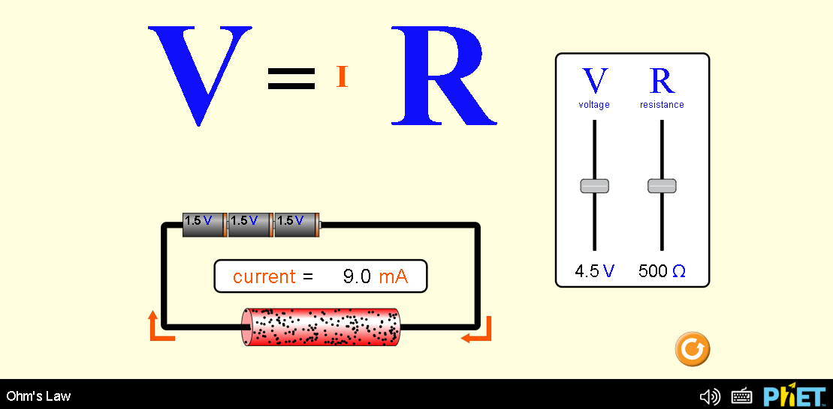
Describe several of your experiments and your observation with captured images from the simulation.
- .
- etc

Demonstrate your understanding:
Directions: As you answer the questions, explain in your own words why your answer makes sense and provide evidence from your #1 experiments. Add more experiments to #1 if you need to get better evidence.

2. If you change the value of the battery voltage:
- How does the current through the circuit change? (answer, explain, evidence)

- How does the resistance of the resistor change? (answer, explain, evidence)

3. If you change the resistance of the resistor:
- How does the current through the circuit change? (answer, explain, evidence)

- How does the voltage of the battery change? (answer, explain, evidence)

4. Consider the two circuits below.
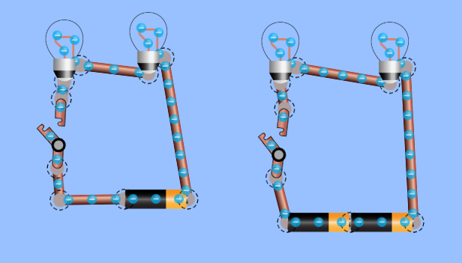
Use your understanding of voltage, resistance, and current to answer these questions:
- What do you think will happen when the switches are turned closed?
(answer, explain, evidence)

- How do you think the lights’ brightness will compare?

- Open the Intro screen of Circuit Construction Kit DC. Build the 2 circuits and check your answers. Insert a capture of the circuits with the switch closed for supporting evidence.

5. Consider the two circuits below.
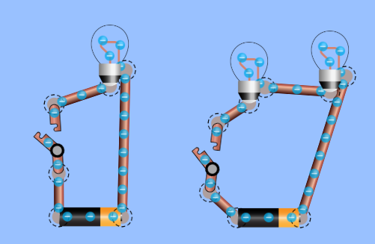
Use your understanding of voltage, resistance, and current to answer these questions:
- What do you think will happen when the switches are turned closed?
(answer, explain, evidence)

- How do you think the lights’ brightness will compare?

- Open the Intro screen of Circuit Construction Kit DC. Build the 2 circuits and check your answers. Insert a capture of the circuits with the switch closed for supporting evidence.

